3D cell-based High Throughput Screening (HTS) using Micropillar/Microwell Chip Platform
Dong Woo Lee, Ph.D.
Assistant Professor, Biomedical Engineering, Konyang University, Daejeon, Korea

In this seminar, I will introduce new 3D cell culture technology, which is suitable to high throughput screening (HTS) with patient derive cells. Monolayer (2D) cell-based assays with human primary cells and immortalized cell lines have been used extensively for in vitro drug efficacy/toxicity testing, and indeed have become routine in drug discovery processes. However, many cells of normal and malignant origin lose some of their phenotypic properties when grown in vitro as 2D monolayer. Compared to 2D monolayer cell cultures, many researchers have already reported that three-dimensional (3D) cell cultures show different morphologies and protein/gene expressions and drug responses. Therefore, in recent years, there have been enormous efforts toward 3D cell cultures that can maintain specific biochemical and morphological features of human cells similar to the corresponding tissues in vivo, including human cells grown within the 3D structure of hydrogel such as alginate, matrigel, and collagen or human cells grown on 3D polymer scaffolds. However, Conventional 3D cell cultures in hydrogels on the traditional multi-well plate platforms are difficult and daunting task to dispense highly viscous hydrogel/cell mixtures into multiple wells and change growth media by aspirating old media out and dispensing new media without disturbing the cell-containing hydrogels. Moreover, primary human cells are expensive and difficult to obtain in large quantities with uniform cell function for conventional high-throughput efficacy/toxicity screens. Therefore, assay miniaturization is an important issue for personalized cancer therapy research due to limited amounts of primary cells from invasive biopsy available for large combinations of therapeutic drugs. To address these technical issues, our group developed a novel micropillar/microwell chip platform (Fig.1), on which 40 nL of cell spots in alginate are dispensed, and then immersed it into microwells filled with growth media for miniaturized 3D cell cultures. This approach easily exchanges media without any damage of 3D cell or hydrogels by replacing microwell chips. To verify the micropillar/microwell chip platform, we screen 24 drugs with three human primary brain cancer cells from patients and compare those results with gene expressions, which will eventually provide a valuable insight into personalized therapy research of each cancer patient

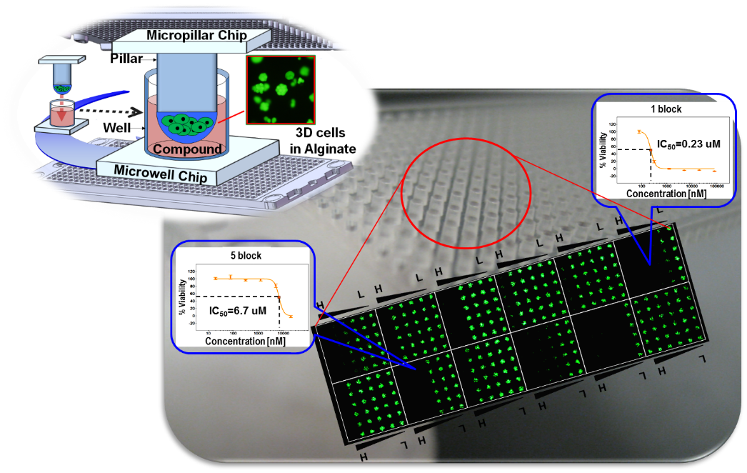
Fig.1 Micropillar/Microwell chip platform for 3D cell-based high throughput screening.

